**Aceinna GNSS Regression Test System**

Yihe Li

2019-03-19

**Regression Testing System**

GNSS Regression testing system is designed to re-running an existed dataset to ensure that previously developed and tested software still performs after a change. The system includes dataset, core algorithm and scripts.

Datasets may include real-time data and post-processing data.

core algorithm may PPP, RTK or PPP(RTK)/INS.

Script parts includes matlab or other scripts to enable batch processing and plots.

This is an initial version which has the following features

1. real-time full constellation PPP batch processing based on rtknavi
2. ambiguity fixing (GPS, GAL, Beidou)

3. supports multiple ntrip casters.

**Usage Introduction**

1. taskkill.exe in C:\Windows\System32. If no, copy taskkill form (rtklib folder)\RTBatchProc to C:\Windows\System32.
2. open matlab as administrator
3. make sure ppp.conf, rtknavi.ini and rtknavi.exe in (rtklib folder)\RTBatchProc.

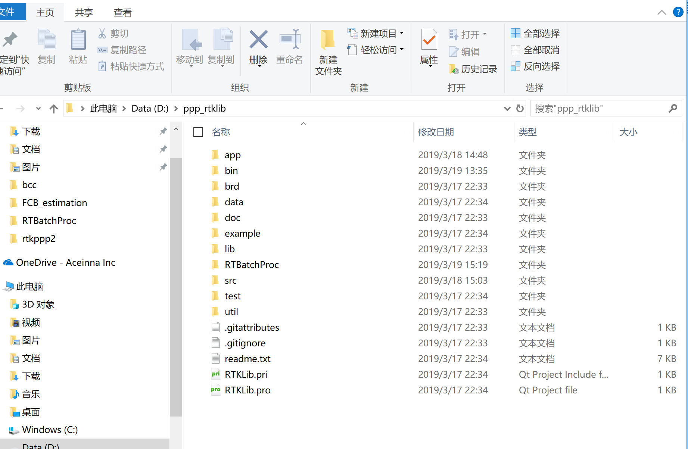

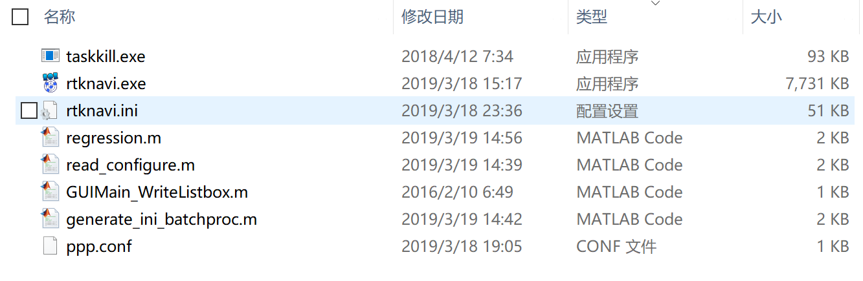

1. Edit ppp.conf

Line 2: Number of station =4: batch processing station number

Line4: && station: 3 means number of input parameters, can be different by station

inpstr1-path: keyword for obs data stream

inpstr2-path: keyword for ssr stream

inpstr3-path: keyword for brdc stream

The information in ppp.conf will cover the ini file for each obs data

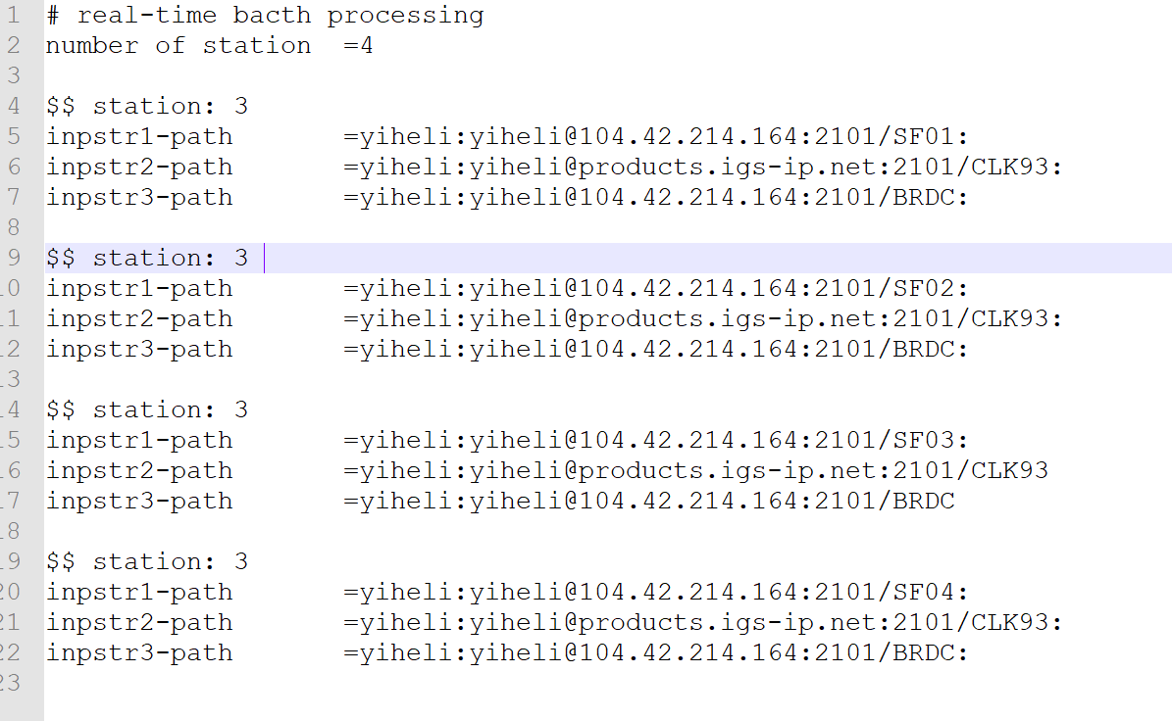

1. Edit rtknavi.ini

rtknavi.ini is original file in rtklib which store configure information for each processing. In regression system, rtknavi.ini is used to store common configuration for all obs data processing. Then individual changes in ppp.conf will cover the same parameters.

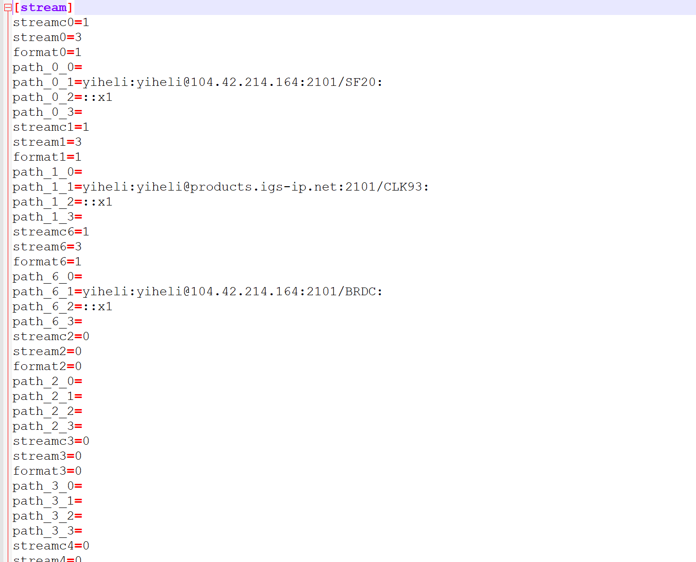

1. Run regression(proc_time)

proc_time is processing time. If regression is run beyond this processing time, it will automatically stop and kill all rtknavi process in the background.